A New Classical Approach: Toward an Integrated Pedagogy
It would be to the mutual benefit of all parties involved to first identify the stakes of this discussion, after which I will officially nail my colors to the mast: the development of the student is the foremost concern, at least in theory, of all pedagogues, regardless of discipline. What is up for debate, however, is the purpose of that development. Contemporary models of education orient themselves around the development of the student in the service of the student themself, in effect treating the academy as a means to some end such as employment but also, among other things, the esteem and satisfaction of the individual students qua individuals. These pedagogies are frequently referred to as student-centered approaches, and are derived primarily from critical theories stemming from the work of the Frankfurt School. In juxtaposition, classical pedagogies orient themselves around the development of the student in the service of knowledge, the historical tradition of the academy that announces itself in the telos of one of its more accomplished albeit currently troubled institutions, Yale University: Lux et Veritas, "Illuminate Truth." These models, which are perceived as "top down" approaches to education, are frequently referred to as teacher-centered approaches, a misnomer that I hope to reconcile in due time (Lathan). The battle between these two positions has been a long one, conservatively dating back to the era of Herbert Marcuse, so I would not imagine it controversial to say that student-centered approaches have, at the very least, gained significant footholds in educational theory, although it is hardly evident that that shift has been to the benefit of students. One need only point to the alarming rates of remediation on college campuses as evidence of this claim.
I fear that by theoretically centering our pedagogical approaches around the students as particular individuals too early, we have turned our back on what it is that our students need the most, and that this course of action has led to a profound sense of angst and alienation within the once hallowed walls of academia, sentiments that can only lead to one result: anomie. I believe there is a way to circumvent the instability of the moment in which we have found ourselves. I want to persuade you that structures of competency matter in the classroom, that classical approaches to education are not systems of fixed and static principles as some might lead us to believe, but an interconnected web of vibrant and dynamic philosophical principles that invite students to participate in discourses relevant to the current milieu while reinvigorating the dialogical partnership between those who are living, those who are dead, and those who have yet to come. Disregarding popular opinions that would construe pedagogical classicism as outdated and ineffective in the best case (Young) and oppressive in the worst (Bostick), classical principles simultaneously ground and support the nuanced, critical perspectives that are so popular in Western education today, and in that way are an essential component of a well-composed educational model in the same way that the Palladian arch remains an essential component of architectural theory. Classicism offers students, among other things, a tradition where they can belong, and it is in that sense of belonging that they will ultimately find themselves. Nowhere is this more evident than First Year Writing (FYW) classrooms.
Educational Architectures
I should like to begin my defense of classical principles in FYW classrooms by stating quite frankly and openly that the presence of a singular and dominant pedagogy will not do, that research, industrial and progressive lenses of education are just as important as classical lenses and vice versa, but that currently the necessary balance between the two has skewed wildly toward the left. This imbalance, I suspect, has much to do with misconceptions about notions of "classicism" and "conservatism" in intellectual spaces. My suspicions are buttressed by a series of horrible misnomers that are generally applied to classical theory and its adherents, the most notable of which being Freire's critique of the "banking" model of teaching where the "bank-clerk educator[s]" are responsible for "'[filling]' the students by making deposits of information which he or she considers to constitute true knowledge," (57), and teacher-centered learning, which prioritizes the experience of the educator by relegating the locus of power to their control (Mugangu and Ssenkusu 17). And although each of these descriptions are correct in the sense that they describe the verticality of pedagogical classicism, where they fall short is in their conceptualization of the nature of the vertical structure and the virtue that situates the pedagogue at the bottom of it all: competence.
One would imagine that all of this talk about orientation will be confusing to the reader, and rightfully so. Not a few sentences ago, I touched on one of the more dominant (if not the dominant) theories of the student-centered world, and now I am quibbling over the "direction" of pedagogical models and where the educator falls within the metaphorical stack. But the fact of the matter is that the architecture of the different pedagogical models is precisely where the intelligence of their respective languages is found. On the one hand there are the horizontally-oriented progressive models of education that stemmed out of the modernist traditions of the early twentieth century, and on the other there is the vertically-oriented classical models that can trace their roots back 2500 years to the Greeks and the development of kalokagathia, the origin of the liberal arts (Williams 4). Make no mistake: both orientations have their respective virtues and need to be considered on the basis of their merits when it comes to pure theory, but as pragmatical methodologies of FYW instruction, the latter serves a precursory purpose that the former cannot and therefore must be considered supraordinate if the holistic development of students is our concern.
I shall attempt to avoid attacking progressive models any more than I already have with the exception of saying that they are deeply rooted in a utilitarian set of principles. To borrow from Louis Sullivan, the famed modernist architect, "form ever follows function," and nowhere is that more evident in writing classrooms that pursue student-centered approaches (Michl 275). The function of such places of learning is the development of the student for their sake, and that reality manifests in the way the courses are taught and the writing that is completed, specifically those proffered by "post-process" intellectuals such as Doug Downs and Susan Wardle. Although I am sympathetic to such positions, notably Downs and Wardle's "Writing About Writing" approach to composition, what I cannot justify is their rejection of "universal academic discourse" as a first-year goal, primarily because there is no such thing as a universal academic discourse as such in a technical sense, and secondarily because to attempt to deny certain aspects of linguistic continuity would be to deny academia's status as a unique discourse community. In a sense, focusing first-year efforts on writing about writing would be no different than teaching first year footballers to commentate on the sport while trying to play the game at the same time: by paying short shrift to the latter, the former will inevitably suffer (and vice versa). The best way to learn to play the game is to play the game first, and analyze the rules later. Piaget taught us that in 1975: an equilibrated state is an "intimate union of constructions and compensations," but compensation can only occur after the groundwork of the initial construction is first laid and settled (40). Progressive models of teaching do not recognize this important idea, but instead criticize it for proliferating "academic communities and discourses [that are] fixed, static entities to which [students] must adapt rather than [question]"(Mutnick and Lamos 25). The result is an environment that, despite its claims to equitability, features sublimated loci of "power" in place of the discrete loci of the classical language.

We can observe this principle in the works of modern architecture, notably Philip Johnson's "Glass House," constructed in 1949 in New Canaan, Connecticut (see Image 1). I will not go so far, as the late Sir Roger Scruton does, as to imply that architecture of this sort contributes to or participates in a "cult of ugliness," although I find it hard to disagree with this sentiment when I consider other modernist buildings such as the tenement housing structures of New York City, or the The Cité Radieuse built by Le Corbusier in Marseilles, France ("Why Beauty Matters" 1:46). I do, however, agree with Scruton when he states that common structures of the modernist and post-modernist era feature no aesthetic guidelines, their "buildings face in no particular direction, and offer no coherent aspect, no over-mastering composition, from whatever angle they may be viewed" ("Classicism Now" 173). Such is the case with Johnson's "Glass House." Those who gaze upon the "house" are greeted by a structure devoid of discernible points of entry, an effect of the structure being composed entirely from similarly styled, recessed, horizontal panes of glass mounted to identical steel beams. What we are left with, in Johnson's own words, is an alien "symmetrical cage" with an asymmetrical internal structure, where each room is defined and composed by a fixed furniture plan meant to juxtapose the ever-changing (ironically vertical) wilderness surrounding the structure. Of course, the glass construction is meant to stress the sense of transparency between the inhabitants of the house and the external world, to promote oneness with the surrounding nature. That said, he contrived nature of its existence—its raison d'être came as the result of a discussion with Ludwig Mies van der Rohe after all—makes the house all but unlivable in any sensible way, which is not to say that the structure is totally useless, only practically useless. That kind of usefulness is as ephemeral as the language that gave rise to it, and that is precisely why the "house" has been relegated to the status of an excessively expensive hotel room. Imagine it: for the low, low price of thirty-thousand dollars, you too can spend a night in this living piece of art, complete with a complimentary dinner and breakfast (Dangremond). Aside from the irony of becoming a bourgeois commodity, the practical uselessness of the structure is compounded by the physical failure of its impractically leaky roof, leading Johnson to jokingly refer to it as "the four-bucket house" ("10 of the Most Iconic").
Image 1: The Glass House (Biondo)
Similar sentiments can be expressed toward progressive writing pedagogies as a whole: their pursuits are intrinsically self-centered in a literal sense. By eliminating or problematizing historically preliminary concerns about genre, rhetorical modes or argumentative praxis i.e. "classical traditions," these modes of writing education attempt to develop students' ability to be transparent about any number of issues that pertain to them through their writing, whether it be hegemonic power in the case of the critical fields, the rejection of standard "academic English" in favor of "authentic" modes of discourse in the case of expressivist pedagogy, or autoethnographic responses to the practice of writing such as the previously described "Writing About Writing" curricula. These are all noble endeavors; I cannot stress my admiration of such goals despite my differences with some of their more notable proponents. However, the fact of the matter remains that all of the same problems that plague Johnson's horizontally oriented "Glass House" can be accounted for in progressive models of education, specifically the presence of vertical albeit diffuse "power" structures set upon a largely indiscernible foundation. The reason this is so unsettling to me as a scholar is that each of these internal structures are effectively concealed from the student; the student develops under the pretense of equity and their own intellectual autonomy but in reality they are entrapped in a clear, symmetrical cage that promotes ideas of idiosyncratic thought patterns while still demanding that the contours of those patterns align with fixed "furniture plans" i.e. ideologies. In this way, progressive pedagogies fall prey to the same failures as Marxist theory according to Paul Ricour:
The paradox is that [progressive education] after [Freire] is the most extraordinary exemplification of [its] own conception of ideology as the sustained expression of the relation to reality and as the occultation of that reality. (198)
By attempting to develop students who are critically consciousness of various issues, personal and public, the writing pedagogue who stresses "transparent self-reflection" of their pupils forces the ideological condition upon their pupils, thus distorting the telos of their aims while producing texts as practically useless as Johnson's "Glass House" in the process.
Conscientious readers may have noticed that I place the word "power" in scare quotes. That is because I find the whole premise of power, at least as it is construed today, to be the product of preposterously cynical readings of the philosophy of Michel Foucault (and by proxy, Friedrich Nietzsche). Granted, Foucault's aim, by his own admission, was to locate power structures and the way those structures discursively normalize certain concepts over others—in Foucault's case, issues related to "sex" (299). My "hang-up," if you will, is in the subtle questioning by Foucault and the not-so-subtle questioning by those influenced by him such as Louis Althusser about the legitimacy of power. Power, according to Foucault, is not held by individuals but diffused into society and given voice through sets of norms that govern everyday life. It is something that everybody is subject to albeit to different degrees, and that in order to become autonomous individuals, at least to the extent that such a thing can be achieved, it is in each of our best interests to develop awareness of all the variety of ways we are subjected to power.
Ironically, even if I tend to disagree with Foucault on a great many things, I am sympathetic to this concern. Of course every subject is beset on all sides by unequal distributions of power; of course those distributions affect the way those subjects either choose to act in the case of a negative relation or influence other subjects to act in the case of a positive relation. If we were an intelligent species, something we pride ourselves on although something I grow increasingly skeptical of, it would be to our collective benefit to understand the dynamics of those relations in order to expunge those that we deem unjust while buttressing those we deem noble. Foucault seems to ignore the latter possibility altogether. Where Foucault falls short, and perhaps I am wrong about this, though I do not believe that I am, is in the subtext of his philosophy, a subtext that belies a deep cynicism toward any form of power. As somebody who shares certain immutable characteristics Foucault—as a gay man, I too experienced literal systemic oppression in the form of "Don't Ask, Don't Tell"—that cynicism is understandable if not ill-founded and specious, especially when one considers the ramifications of corruption and nepotism in global politics. And while we most certainly can maintain the same cynicism toward the forebears of the contemporary academia, doing so, I believe, would be unjust and unrealistic to the same forebears who contributed, in no uncertain way, to the fundamental stability of the academic enterprise as a whole. We don't include the names Aristotle, Shakespeare, Russell or Chomsky in our curricula because they were the beneficiaries of some sociological injustice that came at the expense of others. We include them because of their competence within their respective fields of specialization.
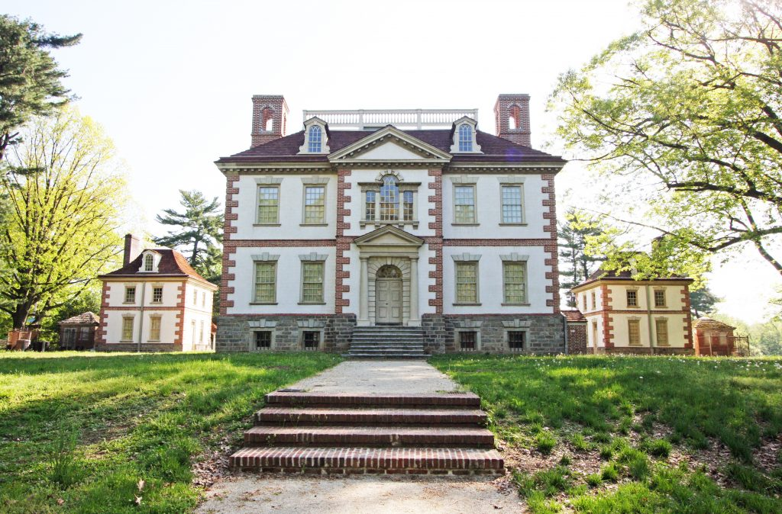
It should come as no surprise then that competency plays an intrinsic role in both classical pedagogy and architecture. Consider the Mount Pleasant Mansion in Philadelphia, Pennsylvania, an exemplar of Georgian architecture designed by Thomas Nevell with the aid of Edmund Wooley, the architect of Independence Hall (see Image 2, "Fairmount Park Houses"). At the expense of sounding nostalgic and somewhat biased, there is an authenticity to the mansion that is not present in Johnson's house: the mansion does not attempt to make itself seem as if it is a necessary part of its natural surroundings, and in doing so it conveys a sense of fittingness that cannot be ascribed to the uncanniness of the Glass House. The most striking feature of the mansion, aside from general aesthetic features such as the brick quoin adornments used to accentuate the masonry, is the portico structure, which houses a traditional Georgian door and transom flanked by a pair of Doric columns that support the entablature and pediment above. Although it is not the foundation of the building itself, the portico is the defining feature of the external facade in that it dictates the entirety of the structure from the bottom up, emanating upward from the foundation and repeating itself along various points of the edifice. Typical of their kind, although perhaps not as exaggerated as their precursors such as those found at the temple ruins of Paestum, is the entasis or intentional swelling of the columns toward the base, a feature used to eliminate the unfortunate optical illusion of thinning of the column. Although this practice is purely aesthetic, it does serve an important purpose by reifying the strength of columns as competent transmitters of the compressive load of the structure above to the foundation below.
Image 2: Mount Pleasant Mansion, Philadelphia ("Park Events")
Hopefully the reader will have noticed that at no time do I ever make reference to a singular column in my disquisition. That is by design. Similar to the relative weakness of vertical structures diffused into horizontal constructions, a single column would be as inept at propping up the weight of a superstructure as a simple number two pencil would be at propping up a human or an elephant. Even if the issue of balance could be addressed, the column would be crushed under the immense weight of the thing it was meant to support before it could ever be considered a viable structure. The important thing here is to recognize that columns, like fish, zebra and humans, are exponentially stronger in numbers, and that is precisely why classical modes of education rely on an array of columns to convey their theories. Seven to be exact. The most concise description of these columns or "areas of development" are laid out by Brian Williams in the inaugural issue of Principia: intellectual; moral; aesthetic; spiritual; physical; practical and social (2). Each area of formation, says Williams, concerns itself with a governing question—for instance, with respect to the intellectual domain the question "What should we know?"—as well as the goal of each area, its associated virtues and vices, and most importantly the danger associated with the column should it be pursued exclusively (3).
Classicism posits that the columns (or pillars) of any particular educational view represent the "first principles" of student development. In the case of industrial, research, or progressive models of education, the first principles transmitted to the students are inherently narrow and oftentimes obscured by the function of the structure itself, which ultimately delimits the growth of the student because they begin their journey with very little material to work with in the first place. However, if the principles are both broad and discrete, then even if students ultimately disagree with those principles in the end analysis, they will still have something to build upon that is sturdier than their own youthful ruminations.
Those attuned to the contours of writing pedagogy might detect similarities to Stanley Fish in my writing, a scholar who has developed something of a reputation for his implacable views about the primacy of form in writing. The crux of Fish's argument is simple: “composition courses should teach grammar and rhetoric and nothing else,” a perspective he anchors with the rather polemical belief that "content is always the enemy of writing instruction" (Save the World 44, 46). I am no more in favor of this approach in isolation than its opposite, nor would be, I would imagine, any classical scholar worth his weight in pencil shavings. To return to an earlier simile, that kind of ugly, first-year writing orthodoxy is tantamount to forcing first year footballers to learn FIFA's entire rulebook before allowing them on the pitch, which again forces me to reassert the same principle, namely that the best way to learn to play the game is to play the game first, and analyze the rules later. Much as I love the classical language, by turning it into a dogma, we reduce writing the status of an inviolable, unimpeachable and sacrosanct fetish not to be touched by the filthy hands of the undeserving or uninitiated.
Teaching Writing: A Palladian Approach
The issue that I hope I have brought into focus by this point, to borrow from a hero of mine, Stephen Fry, is that all of this pedagogical monism, monism perpetuated by thinkers like Fish, Wardle, Burnham and Powell as well as many, many others, "has got to stop . . . above all, this with us or against us certainty . . . [It] is time for this toxic, binary, zero-sum madness to stop before we destroy ourselves ("Political Correctness" 31:22–32:15). I am sure that borrowing this quote from Fry—a practice I do not apologize for—will be construed by theorists on both sides of the issue as unnecessarily catastrophizing the matter to stake some idiosyncratic claim on the silhouette of the pedagogical wilderness, but to that I point to the ever-expanding fissure in the attitudes of people outside the walls of our benighted institutions as well as those among us within the confines who see the metaphorical writing on the wall. How else can we explain away the ideas of people like Jonathan Haidt, a specialist in organizational psychology, who claim that universities, at this point, must choose between the polemically opposed teloi of truth and social justice, since it seems increasingly implausible for the two goals to be pursued within the same space (2:10). Something has to be done, it has to happen now, and it has to happen from the bottom up, since, as I point out elsewhere, the whims of the academic bureaucracy will forever be in tune with whatever "virtue" happens to be the flavor of the day (REDACTED UNTIL COMPLETION OF REVIEW 17). That is why FYW is such an invaluable moment in the curriculum vitae of every student: it sets the metaphorical stage for everything to come by acting as the pedestal upon which the rest of their education is fashioned.
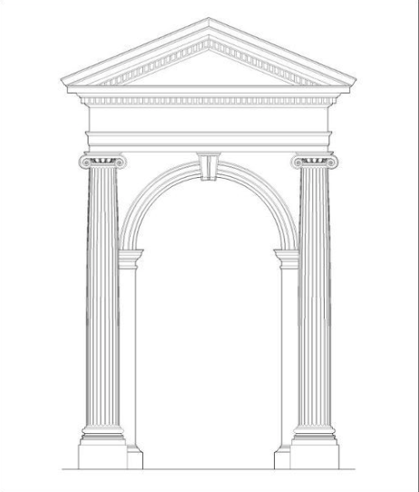
One of the things that I appreciate about Williams' article is the idea that the classical model of liberal education promotes the development of "whole persons," however, and this may come across as nitpicking on my part, the failure of this simplistic design is that it posits the "ends" of each area of formation as if each end were relegated to those areas alone and not part of the array of virtues and skills that constitute the individual in their particularity. In essence, what I am saying is that particular students—and every student is ceaselessly and out-standingly particular—are the end result of a process of living, and as such represents a pinnacle or focal point of sorts that the domain or pillar model fails to address, or at least does so in an unsatisfying manner. In the following paragraphs I would like to lay out a rough schematic for a writing pedagogy that begins with vertical (classical) structural elements before graduating to horizontal (progressive) structural elements with the aim of developing individual students, not just as writers, but as conscientious coparticipants in society. At the risk of drawing my progressive friends' ire, the image I will use as a model for this method of instruction will be that of the classical Palladian arch (see Image 3). Important to the matter at hand are the foundation and columns, and the entablature. Each element represents a generalized timeframe and associated mode of development, with the lower portions of the structure representing the first two years of writing instruction. Naturally, this pedagogical approach, like all pedagogical approaches, is susceptible to the problem that plagues every "science" to one degree or another, namely the contradiction of applying a system of general principles to a unique human being. I believe Carl Jung said it best when he said that "the real picture," in his case the picture of a patient, "consists of nothing but exceptions to the rule, and that, in consequence, absolute reality has predominantly the character or irregularity" (8). The same holds true for students, which is why the pediment (which I am quite unable to discuss at present) represents the apotheosis of their intellectual persona, its breadth and angulature symbolic of the idiosyncrasy of their being. That being the case, I would suggest that every pedagogue, regardless of orientation, learn to roll with the figurative punches.
Image 3: An Arch in the Ionic Manner (Shue)
Basic presupposition: the development of the student is in service of knowledge and as an interlocutor of a historical conversation that manifests in the form of a living tradition. This is the basic axiom of classical theories of education, and it accords with scholars of initiatory practices such as Julie Diamond, whose more expressive pedagogical model privileges "authentic work that respects the condition of the child and an emphasis of the pairing of tradition and critical approaches" as well as the proverbial captain of the old guard of educative philosophy, R.S. Peters, whose work saw him attain stations at some of the most prestigious institutions including Harvard, Kings College of London, and the University of Cambridge (Luntley 53). Peters' philosophy of education can be summed up quite simply: "all education can be regarded as a form of 'socialization' in so far as it involves initiation into public traditions which are articulated in language and forms of thought" (Education as Initiation 13). The autonomy of the student is the goal for Peters and for myself, but the student "cannot [become autonomous] unless [they] have mastered the moves perfected by [their] predecessors" (46). What this means is that the pursuit of education is not just an end in itself, although it ought to be treated as such, but that it is also a form of telluric womb that represents a paradigmatic return to primordial chaos as well as resurrection into “a new spiritual life” within the tribe (Eliade 196). Given that the notion of "community" cannot be extricated from the educative process, ethics not only becomes necessary, it is an essential and preliminary component of the entire endeavor.
This leads us to the first strata of the "Palladian" model of writing education: the foundation and its columns. The reason that I mention the two structures in tandem is that although they are entirely different in essence, they are intimately connected at the pedestal, and therefore inseparable. Ironically, the foundation of a student is just like the foundation of any other structure in the sense that it is the structure that people most often take for granted, only announcing itself when some glaring hole has opened before them, prompting them, in many cases, to avoid said problem until it becomes much too large to ignore. The same can be said for individual ethics and morality: while there are certainly people in the world who make a habit of commending the virtuous acts of others, more often than not the only attention paid to the ethics of another person occurs when their moral framework is found wanting, a deeply anti-human pattern of behavior I might add. As such—and this will undoubtedly be the most impractical point I will make over the next few pages due in no small part to administrators' unwillingness to fiddle with general education curricula—moral education and ethics must serve as the initiatory practice and subsequent foundation of any successful FYW writing program.
For the moment it would be useful to clarify what I am not saying: what I am not saying is that schools should explicitly mandate philosophical education for their students as part of their general education, though I do believe it would be to their great benefit, nor am I suggesting that every pedagogue become a "philosopher" in their own right in order to properly teach students to write. It would be impractical and arrogant of me to suggest otherwise, impractical in that it would be demanding too much of the institutions to assert that kind authority over their students at thei own (likely fiduciary) expense, and arrogant in the sense that I seem to be embedding my own intellectual pursuits in a seemingly unrelated issue. Neither of those are the case. What I am suggesting is that by introducing basic philosophical ideas about morality such as how we arrive at ethical knowledge (Plato's "Euthyphro"), the nature of virtue (Aristotle's Nicomachean Ethics), the harm principle and the concept of utility (Mill's Utilitarianism), and the deontological formulations of the categorical imperative (Kant's Groundwork for the Metaphysics of Morals), educators can raise awareness not just of the manner of thought that led to such ideas but possible resonance between those thoughts and the students' own moral compasses. More importantly, basic exposure to general ethical principles will present students with the possibility that every form of ethics has a claim to viability, making it all the more difficult to dehumanize each other and therefore be dismissive of those with differing views.
In the same way that the foundation situates the columns, the moral education of the student underpins the basic principles of the writing curriculum. The question is: what theories determine the basic principles and why do they take precedence over other theories? The impetus here would be to say that this is a highly subjective issue, and that different theories are interchangeable with others so long as the spectrum of intellectual "virtues" is attended to at some point or another. To assert that, I believe, would be a grave mistake. The fact of the matter is that many prevalent pedagogical theories are more apt as "focal lenses" of sorts than as basic structures of writing instruction. Others can simply be embedded in the foundational perspectives. For instance, although my model is equally distributed across two columns, process pedagogy and genre and rhetorical studies, certain core principles from other approaches—community-engaged pedagogy for instance—are integrated into those columns in the same way aesthetic features like vertical fluting and opposing volutes are integrated into the Ionian order. Aesthetics, as I teach my students, is less concerned with mundane ideas of beauty, and more concerned with the "rightness" of things, which is why it is an axiological theory, and in the case of writing, no text, no matter how well-constructed, qualifies as "beautiful" if it lacks the essential qualifications of belonging to the student-author and while being contextualized by the culture in which is embedded. This is just one way in which educators can promote beauty in the classroom; in my own practice, I give my students the opportunity to volunteer at our campus Writing Center, primarily to shadow the tutoring faculty members but also to lend a hand where possible.
As far as the columns themselves are concerned, focusing on process, genre and rhetoric allows pedagogues to ensure that their students are inheriting a set of vertically-aligned skills that are both historically valid and progressively developed. It goes without saying that the two theories overlap significantly, specifically when it comes to how the student might be tasked with coming to terms with them. With respect to genre pedagogies, Amy Devitt defines three broad approaches that might be extended to the other theories I have mentioned: [1] teaching particular processes, genres and modes of rhetoric; [2] teaching awareness of processes, genres and modes of rhetoric, and [3] teaching critique of processes, genres and modes of rhetoric (147). Unsurprisingly, Devitt and I agree on a great many details about this approach, but none more deeply than the end goal of combining these approaches into a vertically progressive scheme aimed at helping students act rhetorically and consciously within and beyond the situations they will encounter through their lives" (147). The benefit to this schema and what qualifies it as part of a classical approach to writing pedagogy is that it simultaneously develops direct and indirect skills that might be described as the materia prima of competent writers, regardless of discipline or interest.
To that end, I would like to redress the misnomering of classical pedagogues as a "bank-clerk educator[s]" responsible for "'[filling]' the students by making deposits of information which he or she considers to constitute true knowledge," as described by Freire (57). Admittedly, I can see how this view of the classical scheme might have come into its own considering the cultural context in which Freire composed his work and in light of reflections about the matter—reflections that, ironically, do not cast the "classical lecturer" in any demonstratively negative light—by an intellectual hero of mine, Stephen Fry (Moab is My Washpot 218–220). However, I would assert that any castigatory remarks confuse traditions themselves with the executors of those traditions, not all of whom operate in good faith. Contrary to Freire's idea of the bank-teller pedagogue, classical educators privilege, via conscientiously designed lesson plans and assignments, patterns of behavior that support the development of well-rounded students. These can include, but are not limited to, step-oriented approaches to textual development where multiple drafts of a paper are preferable to singular, finished projects; micro-routine development, namely dedicated in-class opportunities for reflective writing as opposed to scripted, uninterrupted and sterile lecturing; an emphasis on physiological and psychological well-being, and an implementation of social learning practices such as group peer-reviewing sessions where students effectively participate in the teaching process. This results in a fundamentally Socratic experience for all parties involved, a push-and-pull ecosystem where one person—the pedagogue—leads, and the other—the students—follows, but both are purposefully engaged in mutual development that will prepare the student for the rest of their academic career while still satisfying the dreaded bugbear in the room: institutional requirements.
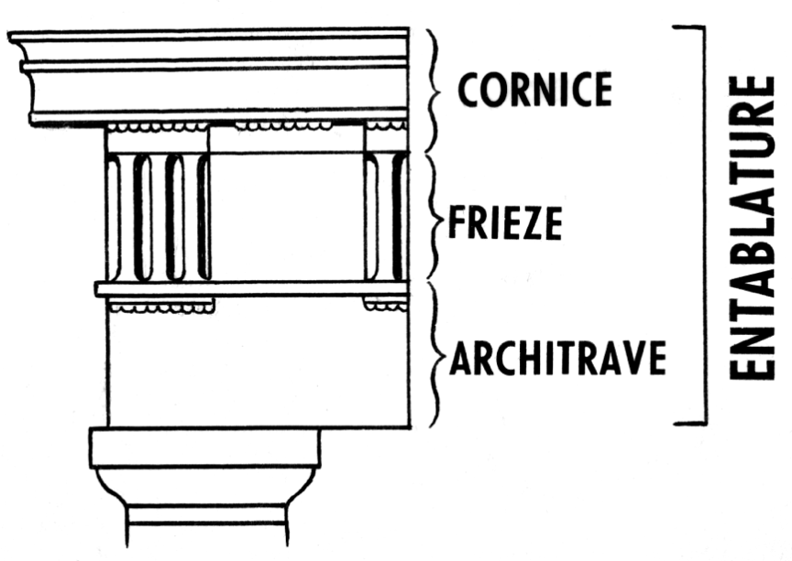
Moving on: If the columns are the foundational structure that develops the basic "form" of the student as a member of the academic discourse community, then the entablature and its component structures—the cornice, frieze an architrave (see Image 4)—are the structural support and “decorative” apparatus of the student as a particular intellectual, which is to say that it represents the array of elemental theories that constitute the students' memetic lineages. Here is where the classical model of pedagogy leaves off, at least to a degree, and critical approaches to writing pedagogy begin, occurring formally around the third academic year, though more pugnacious pupils will undoubtedly explore the theories that appeal to them on their own time. As one such student, I can attest to the scowls of annoyance on my own professors' faces as I would try my hand at some exotic compositional methodology—mimicking the pleonastic rhetoric of Heidegger for instance—although I would argue, and perhaps the scholarly caballeros of West Chester's English studies fiefdom would agree, that such belligerence was ultimately to my advantage, and might be worth encouraging in younger crops of students as they emerge from their tillers. It is a practice I cherish deeply and one that I attempt to incite or instigate in my own students when the opportunity presents itself.
Image 4: Entablature (Terry)
The fact of the matter is that at this point there is nothing else I can say about what pedagogical models one ought to employ, since, in all likelihood, each of us is the recipient of and vector for our own memetic lineage. What works or is appealing for one of us will not necessarily work for another, is anathema to another, and is something of utter indifference to somebody else besides. My only word of caution to every educator, not just those with differing views than myself, is to be conscious of allowing the ideology of your pedagogical framework to become the substance of the course itself. This, I imagine, should seem to go without saying, but given the current climate surrounding higher education and the recognition, even from those leftwise of myself, that the homogeneity of our institutions—a fact that can no longer be disputed—is polarizing students in ways that we will not be able to comprehend until it is too late, it is a statement that needs to be stated clearly, stated frequently, and stated in earnest (Hoffman).
It would be ridiculous to attempt to move forward without taking a moment to address the major hindrance associated with this particular approach to writing education. For instance, I doubt that many educators will be fond of the difficulty associated with pedagogical multitasking in the classroom. This, however, is a minor inconvenience relative to the much more pernicious problem of time, or lack thereof. How, after all, does one educator employ multiple pedagogical practices over the course of a semester while still maintaining coherency from lesson to lesson as well as with departmental expectations. The key is to conscientiously scaffold longitudinal lesson plans: in my own teaching, semesters are broken up according to the major assignments—my FYW students write an exploratory essay, a formal argument, and a rudimentary analysis—and as each subdivision progresses, the students move beyond their initial role as passive observers toward greater autonomy where I effectively step back and allow them to "take over" when it comes to key social practices.
In terms of work, the earliest stages are hallmarked by in-class discussions and readings that exemplify the genre at hand or writings about that genre, but as the block moves forward the students are afforded more time to write in class, to participate more actively in the decision process when it comes to reading selections, and move from guided group review sessions to peer-review work that is all but totally autonomous. This allows me, by the time the final peer-review rolls around—about a week prior to the due date of each assignment—to introduce particular critical lenses that the students and I can use in our discussions about that week's reading. A favorite theory of mine, as anybody who knows me will attest to, are the various psychoanalytical approaches to criticism proffered by people like Freud, Jung and Adler, but to each their own I say. By this point in the semester the students should have earned their sea-legs, so to speak, and even if they have not, they would certainly be familiar with the overall process and where to go for help should they need it in order to properly marshal themselves and navigate the choppy waters outside the safe harbor of uncritical composition.
Concluding Thoughts
What I have attempted to do with this essay is illustrate, descriptively as opposed to prescriptively, a pedagogical framework for writing composition focused on the needs of FYW students as opposed to orienting itself around the students themselves, most of all the contextually external identities that the carry with them. This dynamic has been described as contrasting student-centered and teacher-centered approaches, nomenclatures I deny in as vehement a manner as possible. The reason for my emotional response is that the student-centered models of pedagogy, to me, smack of a self-centeredness both on the part of the educator and the student. In isolation, they neither serve the essential telos of higher learning nor do they serve the best interest of the student, which is to say that such approaches provide shallow instruction in core skills that students will need not just in academia but the world at large in the best cases, and in the worst cases—and I shudder to think of our complicity in the current state of worldly affairs—they promote conditions amenable to the development of psychological complexes, specifically complexes of the ego (Jung 41).
It is ironic that practitioners of progressive methods view classical methods of pedagogy and the environments in which they are embedded "as fixed, static entities to which the student must adapt rather than questioning how the institution itself is produced by asymmetrical power relations that . . . reinforce oppressive or stereotypical attitudes and ideologies" (Mutnick and Lamos 25). The truth of the matter cannot be farther removed: "the beauty of university life," writes Stephen Fry, about the culture of academia, is that you "learn on the job and you learn from the second-years and third-years above you, who in turn learned on the job from those above them" and so-on-and-so-forth ad infinitum, provided, of course, that we don't muck up the whole enterprise in our desire to run without first learning to crawl (The Fry Chronicles 96). However, running is ultimately the goal I suppose, and in the same way that crawling is the precondition of upright ambulation, so too are classical approaches to writing with regard to more nuanced progressive theories about writing. Without the one, the edifice of the structure presented to the students lacks adornment and is therefore not a fully-formed character, but without the other the structure is little more than a superficial hovel.

Works Cited
"10 Iconic Buildings That Demonstrate Modern Architecture at Its Finest." Arch20, https://www.arch2o.com/10-most-iconic-buildings-modern-architecture/. Accessed 15 Mar. 2023.
Biondo, Michael. "Glass House, 1949." The Glass House, National Trust for Historic Preservation and The Glass House, https://theglasshouse.org/explore/the-glass-house/. Accessed 25 Feb. 2023.
Bostick, Dani. "The Classical Roots of White Supremacy." Learning for Justice, no. 66, 2021, https://www.learningforjustice.org/magazine/spring-2021/the-classical-roots-of-white-supremacy.
Dangremond, Sam. "How to Spend a Night at Philip Johnson's Glass House." Town & Country, 18 May 2016, https://www.townandcountrymag.com/leisure/travel-guide/a6220/sleep-in-philip-johnson-glass-house/.
Devitt, Amy J. "Genre Pedagogies." A Guide to Composition Pedagogies, 2nd ed., edited by Gary Tate, Amy Rupiper Taggart, Kurt Schick, and H. Brooke Hessler, Oxford University Press, 2014, pp. 146–162.
Eliade, Mircea. The Sacred and the Profane. Translated by Willard R. Trask. Harcourt Brace, 1987.
"Fairmount Park Houses." Philadelphia Museum of Art, https://philamuseum.org/visit/locations-hours#historic-houses. Accessed 27 Feb. 2023.
Fish, Stanley. Save the World on Your Own Time, Oxford UP, 2008.
Foucault, Michel. "We 'Other' Victorians." The Foucault Reader, edited by Paul Rabinow, Pantheon, 1984.
Freire, Paulo. Pedagogy of the Oppressed, translated by Myra Bergman Ramos, The Continuum Publishing Company, 1993.
Fry, Stephen. The Fry Chronicles: An Autobiography. The Overlook Press, 2012.
---. Moab is my Washpot: An Autobiography. Random House, 1997.
Haidt, Jonathan. "Universities must choose between TRUTH or Social Justice, not both - Jonathan Haidt." YouTube, uploaded by Gravitahn, 5 Dec. 2016, https://www.youtube.com/watch?v=kaQ-ZF9S3uk.
Hoffman, Adam. "My Liberal Campus Is Pushing Freethinkers to the Right." The New York Times, 1 Mar. 2023, https://www.nytimes.com/2023/03/01/opinion/campus-conservative-
Jung, C.G. Psychogenesis of Mental Disease, translated by and R.F.C. Hull, edited by Gerhard Adler, Princeton UP, 1960, https://archive.org/details/psychogenesisofm03carl freethinkers.html.
Langbert, Mitchell. "Homogenous: The Political Affiliations of Elite Liberal Arts College Faculty." National Association of Scholars, 2018, https://www.nas.org/academic-questions/31/2/homogenous_the_political_affiliations_of_elite_liberal_arts_college_faculty.
Lathan, Joseph. "Complete Guide to Teacher-Centered vs. Student-Centered Learning." Today's Adult Learner, University of San Diego, https://onlinedegrees.sandiego.edu/teacher-centered-vs-student-centered-learning/. Accessed 17 Feb. 2023.
Luntley, Michael. "On Education and Initiation." Journal of Philosophy and Education, vol. 43, no.1, 2009, pp. 41–46, https://doi.org/10.1111/j.1467-9752.2010.00764.x.
Michl, Jan. " E. H. Gombrich's Adoption of the Formula Form Follows Function: A Case of Mistaken Identity?" Human Affairs, vol. 19, 2009, pp. 274–288, DOI: 10.2478/v10023-009-0041-9.
Mugangu, Lawrence, and Peter Ssenkusu. "Teacher-Centered vs. Student-Centered: An Examination of Student Teachers’ Perceptions About Pedagogical Practices at Uganda’s Makerere University." The Politics of Contemporary Education, vol. 11, no. 2, 2019, https://doi.org/10.18733/cpi29481.
Mutnick, Deborah and Steve Lamos. "Basic Writing Pedagogy: Shifting Academic Margins in Hard Times." A Guide to Composition Pedagogies, 2nd ed., edited by Gary Tate, Amy Rupiper Taggart, Kurt Schick, and H. Brooke Hessler, Oxford University Press, 2014, pp. 20–36.
"Park Events." Fairmount Park Conservancy, https://myphillypark.org/event/mt-pleasant-tour/. Accessed 27 Feb. 2023.
Piaget, Jean-Luc. The Development of Thought: Equilibration of Cognitive Structures, translated by Arnold Rosin, The Viking Press, 1977.
Peters. R.S. Education as Initiation: An Inaugural Lecture Delivered at the University of London Institute of Education, 9 December, 1963, Evans Bros., 1964.
"Political Correctness Debate ft. Stephen Fry, Jordan Peterson, Michael Dyson, Michelle Goldberg." YouTube, uploaded by Truthspeak, 19 May 2018, https://www.youtube.com/watch?v=GxYimeaoea0&t=2002s.
Ricour, Paul. Hermeneutics and the Human Sciences: Essays on Language, Action and Interpretation, translated by John B. Thompson, Cambridge UP, 2016.
Rothman, Stanley, S. Robert Lichter, Neil Levitte. "Politics and Professional Advancement Among College Faculty." The Forum, vol. 3, no. 1, 2005, http://www.bepress.com/forum/vol3/iss1/art2.
Scruton, Roger. "Classicism Now." The Roger Scruton Reader, edited by Mark Dooley, Continuum, 2011, pp. 163–174.
---. "Why Beauty Matters." Vimeo, uploaded by Leonardo Faccioni, 2015, https://vimeo.com/128428182. Accessed 25 Feb. 2023.
Shue, Greg. "An Arch in the Ionic Manner." Pinterest, 2 Feb. 2012, https://www.pinterest.com/pin/95701560801430686/. Accessed 27 Feb. 2023.
Terry, James. "Entablature." Art History Glossary, Stephens College, https://blog.stephens.edu/arh101glossary/?glossary=entablature. Accessed 2 Mar 2023.
CITATION REDACTED UNTIL COMPLETION OF REVIEW
Williams, Brian A. "Editorial: Introducing Principia and Classical Education." Principia, vol. 1, no. 1, 2022, doi: 10.5840/principia202211/21.
Young, Vershawn Ashanti. "Should Writers Use They Own English?" Iowa Journal of Cultural Studies, vol. 12, no. 1, 2010, pp. 110–117, https://doi.org/10.17077/2168-569X.1095.

For the purposes of this article, words like classicism, the classical language, classical theory or any other reference should be taken as relating to the classical mode of education.
For instance, although the basic structure of argumentation tends to hold across disciplines, the manner in which those arguments occur may vary according to specific registers. Take my writing for example: the annoyingly bedecked, Swiftian style of writing I am known for would be quite out of place in, say, a biology department or a physics department. It still adheres to certain rhetorical customs and traditions though, and if need be I could alter my writing to fit in a different community on campus.
For the purposes of this article, I have replaced references to "Marx" and "Marxism" with appropriate terms. Otherwise, the quote appears as it does in Ricour's Hermeneutics and the Human Sciences.
In earlier iterations of this article, I included the arch as representative of literature, since I believe great pieces of literature—I, myself, am partial to Tolstoy—are effective at belaying the more rigorous coursework, effectively giving the students moments to breath in between deep theory. That said, I would like to think everybody, sociopolitical temperament notwithstanding, can agree on the value of literature in FYW classrooms, therefore I have chosen not to mention it specifically in this text.
Obviously these are the theories I would qualify as "most necessary" for a rudimentary introduction to ethics. However, my students have been greatly receptive of the works of John Rawls as well, notably excerpts from A Theory of Justice, so there is no reason why other readings should not be introduced, provided they do not interfere with the coursework.
That in itself can present a series of problems, especially if said student is drawn to a theory that polemically opposes one's own. However, there is that old saying that steel sharpens steel, and in a place of higher learning it is to everyone's advantage when competing viewpoints engage.
Although they are not the earliest of their kind, studies conducted by the Carnegie Foundation for the Advancement of Teaching in the 1990s make it clear that "the political orientation of the professoriate is tilted toward liberal attitudes and the Democratic Party" (Rothman et al. 13). These findings have only intensified in recent decades. For instance, in his 2018 study about the political leanings of professorial political leanings from fifty-one, top-ranked liberal arts universities, Mitchell Langbert found that the ratio of democratic faculty members to their republican counterparts was "10.4:1 across all liberal arts departments if the military colleges are included and 12.7:1 if the military colleges are excluded" (188).

